Deputy Hearing Examiner Susan Drummond

BEFORE THE HEARING EXAMINER
CITY OF SEATTLE

In the Matter of the Appeal of:  TreePAC Environmental Impact Review  (TEIR) and Greenwood Exceptional  Trees (GET) of the November 15, 2021 Determination of Non-Significance by Brennon Staley, Office of Planning and Community Development (OPCD). |  | |  |  |  |  |  |  |  | |  | Hearing Examiner File:  W-21-007  REVISED FINAL APPELLANTS’ LIST OF EXHIBITS

Following the hearings between February 28 and March 2, 2022, the Appellant’s final list of exhibits include the following exhibits, and common access and acknowledged documents:
APPELLANT EXHIBIT LIST
- The final list of exhibits from the Appellant includes the following:
Appellant Exhibit # : Description
Appellant Exhibit 1: [ H.E. # 40] 2016 Seattle Tree Canopy Assessment
Appellant Exhibit 2: [ H.E. # 21] Exhibit - Seattle's LR MF Zones, Jan 2016
Appellant Exhibit 3: Exhibit - Seattle LR MF Zones, Feb 2020
Appellant Exhibit 4: “Lowrise Multifamily Code Updates: Balancing Design and Density”.
Appellant Exhibit 5: Vehicle Access Easement Standards, SDCI Multifamily LR
Appellant Exhibit 6 Seattle Ordinance 123495 dated December 20, 2010 (pages 1 -40)
Appellant Exhibit 7: “Modeling Urban Impervious Surface Areas in Relation to Urban Heat Island Effects - Research for a Sustainable World”
Appellant Exhibit 8: “Correlations of Stormwater Runoff and Quality: Urban Pavement and Property Value by Land Use at the Parcel Level in a Small Sized American City”
Appellant Exhibit 9: Annotated SEPA Checklist (posted with appeal)
Appellant Exhibit 10: “The Benefits and Limits of Urban Tree Planting for Environmental and Human Health”
Appellant Exhibit 11: Beacon Hill Anti-Displacement Survey
Appellant Exhibit 12: “YIM 1 and YIM 2” Clarify Washington Regulatory Takings
Appellant Exhibit 13: OPCD 2018 Community Planning Prioritization (p 1-4, 28-31)
Appellant Exhibit 14: [ H.E. # 34] Seattle Hearing Examiner decision DNS from W-16-004.
Appellant Exhibit 15: [ H.E. # 49] Lot Coverage Assessment TEIR Alternatives to OPCD notice
Appellant Exhibit 15A: [ H.E. # 49A] Street Trees Only Alternatives to on-site canopy
Appellant Exhibit 16: [ H.E. # 22] 25.05.926 - Lead agency for governmental proposals and SMC 25.05.670 Cumulative effects policy
Appellant Exhibit 17: Market Rate Housing Needs and Supply Analysis , BERK 2021
Appellant Exhibit 18: OPCD Housing Choice Public Engagement Summary, January 2020
Appellant Exhibit 19(A): [ H.E. # 48] LR1 zone case study: 2213NW 63rd St., Seattle, WA
Appellant Exhibit 19B: [ H.E. # 48B] LR1 zone case study: 2045 NW 63rd St., Seattle, WA
Appellant Exhibits 20 [ H.E. # 19]: Expanded information on the OPCD's Core Document Exhibit #7.
Appellant Exhibits 21A-D: [ H.E. # 44] Before /After Images of City Core Document Examples
Appellant Exhibits 22: [ H.E. # 42] Eleven (11) examples at Greenwood and Phinney neighborhood
Appellant Exhibits 23: [ H.E. # 43] Core document trees removed within LR-zoned (2019) Whittier developments site including 8326 13th NW; 8318 13th NW, 8340 13th NW, and 8344 13th NW.
Appellant Exhibit 24: City of Seattle, Proposal Summary Townhouse Reforms, Nov 2021
Appellant Exhibit 25: Nicolas Welch conversation with OPCD staff about trees
Appellant Exhibits 26: June Establishment of Seattle’s Urban Forestry Commission
Appellant Exhibit 27: Beacon Hill neighborhood stats
Appellant Exhibit 28: Clean Heat
Appellant Example 29: Beacon Hill Survey Results
Appellant Example 30. Maria Batayola Profile CV
Appellant Exhibit 31: [ H.E. # __] Martin Kaplan, Architect Profile CV
Appellant Exhibit 32: [ H.E. # __] David Moehring, Architect Profile CV
Appellant Exhibit 33: [ H.E. # 30] William Lider, Engineer CV
Appellant Exhibit 34: [ H.E. # 50] Michael Oxman Profile CV
Appellant Exhibit 35: [ H.E. # 33] Brian Derdowski Profile CV
Appellant Exhibit 36: [ H.E. # 36] Kathleen Wolf Profile CV
Appellant Exhibit 37: [ H.E. # 39] Urban Trees and Human Health: A Scoping Review
Appellant Exhibit 38: [ H.E. # 37] The Urban Forest and Ecosystem Services: Impacts on Urban Water, Heat, and Pollution Cycles at the Tree, Street, and City Scale
Appellant Exhibit 39: [ H.E. # __] Trees Grow on Money: Urban Tree Canopy Cover/ Environmental Justice
Appellant Exhibit 40: [ H.E. # 38] A Conceptual Typology of Practical Design Interventions to Integrate Health and Climate Resilience Co-Benefits
Appellant Exhibit 41: Declaration of Tina Cohen, retired arborist
Appellant Exhibit 42: Declaration of Robert and Mary Jean Gilman, Seattle residents
Appellant Exhibit 43: Declarations of Penny Griffen, Whittier trees
Appellant Exhibit 44: Declaration of David Moehring, 6407 Carleton
Appellant Exhibit 45: [ H.E. # 51] Declaration of Suzanne Grant, 2813 4th Ave W
Appellant Exhibit 46: [ H.E. # 47] Declaration of Woodrow Wheeler, wildlife biology
Appellant Exhibit 47: [ H.E. # 46] Woodrow Wheeler Profile CV
Appellant Exhibit 48: Declaration of Marina Lamps Alvarez
Appellant Exhibit 49: [ H.E. # 20] Moehring Declaration – Seattle LR zoning maps
Appellant Exhibit 50: SMC 25.05.340 - Determination of nonsignificance (DNS)
Appellant Exhibit 51: [ H.E. # 41] Richard Ellison Profile CV
Appellant Exhibit 52: [ H.E. # 26] Department Responses to Interrogatories 1 to 10 (with ‘COS’ number)
Appellant Exhibit 53: Notes SEPA Analysis Townhouse Reform Legisl. COS0004611
Appellant Exhibit 54: [ H.E. # 25] LR1 density analysis COS0004224
Appellant Exhibit 55A: Townhouse Reforms Goal and Principles COS0000004
Appellant Exhibit 55B: Lowrise 1 Density Limit COS0000609
Appellant Exhibit 56A: Townhouse Reforms Next Steps COS0000007
Appellant Exhibit 56B: Check-in and Engagement COS0004290
Appellant Exhibit 56C: Project Schedule COS0000006
Appellant Exhibit 57A: Townhouse Data COS0004353
Appellant Exhibit 57B: Townhouse Data memo COS0004347
Appellant Exhibit 58A: Presentation to Executive Team COS0004426
Appellant Exhibit 58B: Letter to Mayor 10/13/2021 COS0004420
Appellant Exhibit 59 Summary and Fiscal Note COS0000529
Appellant Exhibit 60: Attachment A 9/3/2019 Advisory Council COS0003950
Appellant Exhibit 61: LR1 Layouts Study COS0000562
Appellant Exhibit 62: not used
Appellant Exhibit 63: [ H.E. # 23] City Townhouse Dwelling Count Calcs COS0000586
Appellant Exhibit 64: [ H.E. # 24] City Townhouse Value Calcs per Sq. Ft COS0000589
Appellant Exhibit 65: [ H.E. # 32] Seattle Street and property utility map in LR1 zone example
Appellant Exhibit 66: [ H.E. # 31] Declaration of William Lider, Engineer
Appellant Exhibit 67: King County Capacity Charge Residential Sewer Use
Appellant Exhibit 68: [ H.E. # 36] Seattle i-Tree
Appellant Exhibit 69: not used
Appellant Exhibits 70 to 76R: City discovery tree assessment via October 2019 public records request (14 documents and presentations)
Appellant Exhibit 70: [ H.E. # 29] J. Faith Ramos Public Records List (1 of 3)
Appellant Exhibit 71: Tree Protection per SMC Title 23 and SMC 25
Appellant Exhibit 72: Phase One Site samples Low-rise Tree Protection
Appellant Exhibit 72R: Tree regulations products planting, protection (email cover)
Appellant Exhibit 73 [ H.E. # 28] : Tree Research March 2017
Appellant Exhibit 73R:Notes from 2/15/2017 and Agenda for Final (email cover)
Appellant Exhibit 73RR: Shauna would like to review PPT to share (email cover)
Appellant Exhibit 73S: Slides only of Tree Research March 2017
Appellant Exhibit 74: [ H.E. # 27] Final Report Tree regulations Research Project
Appellant Exhibit 74RR : 2017 follow-up on 2009 Tree Audit
Appellant Exhibit 74RR: Tree Regulations final report (email cover)
Appellant Exhibit 75: 021517 Notes Final
Appellant Exhibit 76: 2013-2014 Tree Benefits Map
Appellant Exhibit 76R:New trees planted in 2014 by Council District
Appellant Exhibit 77: [ H.E. # 45] Seattle Times Article “Bills Would Allow Denser Housing in Single-Family Neighborhoods” and Map graphic, Heidi Groover, dated February 1 and 2, 2022.
Appellant Exhibit 78: [ H.E. # 78] Compiled documents from public access SDCI Electronic Document Management System for City Exhibit No. 9. (reference links in part B item 8 below.)
Appellant Exhibit 79: [ H.E. # __] Images of 2300 W Emerson Street and 3015 30th Ave W

- Included are the applicable documents without copy are the following commonly acknowledged sources of witness testimony:
1. State Environmental Policy Act Handbook, Washington State Department of Ecology; 2. SEPA Training Session Four: “Non-project SEPA, phased review, adopting existing documents”;
3. Urban Forestry Stewardship Plan 2013 (pages 1, 8-25, 29-33, 37-40, 53, 60-63, and 73 of original 79-page document);
4. Urban Bird Treaty letter (adopted June 7, 2017);
5. Seattle Fire Code as amended;
6. All SDCI Director’s Rule including 7-2018 (pages 1-6), Rule 6-2001 and Rule 16-2008
7. CDC website: “Health Effects of Gentrification” including linked documents https://www.cdc.gov/healthyplaces/healthtopics/gentrification.htm;

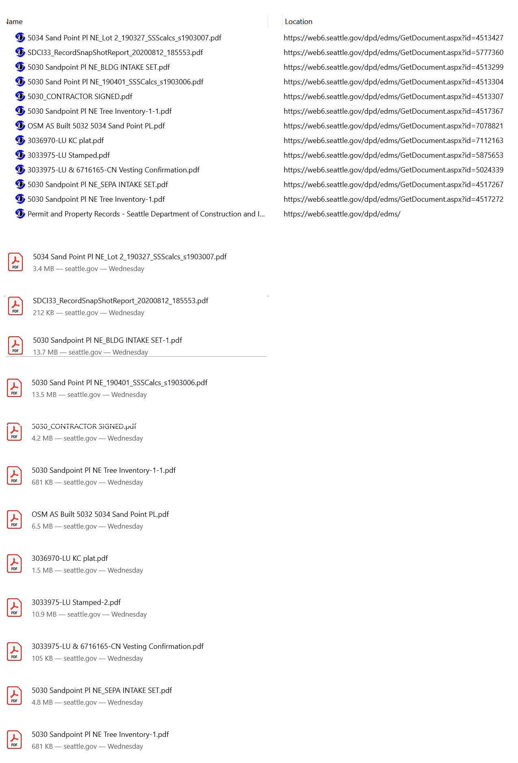
8. As requested at the end of the hearing from the representative of the Seattle OPCD , we are also including the applicable self-discovered documents (without copy) from the SDCI Document Management System documents relative to City Exhibit 9:

The above screenshot is of documents searched from the SDCI Electronic Document Management System, and repeated below are the same files displayed with file size and active links to these documents.
5034 Sand Point Pl NE_Lot 2_190327_SSScalcs_s1903007.pdf
SDCI33_RecordSnapShotReport_20200812_185553.pdf
5030 Sandpoint Pl NE_BLDG INTAKE SET.pdf
5030 Sand Point Pl NE_190401_SSSCalcs_s1903006.pdf
5030_CONTRACTOR SIGNED.pdf
5030 Sandpoint Pl NE Tree Inventory-1.pdf
OSM AS Built 5032 5034 Sand Point PL.pdf
3036970-LU KC plat.pdf
3033975-LU Stamped.pdf
3033975-LU & 6716165-CN Vesting Confirmation.pdf
5030 Sandpoint Pl NE_SEPA INTAKE SET.pdf
- Common access documents:
  - Seattle 2035 Comprehensive Plan Managing Growth to Become an Equitable and Sustainable City 2015–2035, pp. 33-34, 47, 121, 133 and p. 389.
  - Seattle Municipal Code ( SMC ) Chapters 23.24 Shorts Plats and 23.28 Lot Boundary Adjustments
  - Full development site plans for the City’s Core Exhibits 8 to 13 that the Department reported to be available to Appellant through the public portal available online. As referenced by the Interrogatory Response No. 4, these full sets are referenced as evidence to the matter of scope of environmental impact within these six department-provided examples.
  - In context to fully understand the difference between the proposed Department Townhouse Reform Action and the recent 2019 SEPA determinations (without challenging or judgement to past determinations), the public access documents associated with Citywide MHA implementation and Accessory Dwelling Unit regulations are to be referenced. The Final Environmental Impact Statements can be found at the following public documents / links:
    - Compiled_MHA_FEIS_2017.pdf (seattle.gov)
    - MAIN_ADU_FEIS_2018.pdf (seattle.gov)
Not listed herein, all relative sections of the Seattle Municipal Code (hereafter “SMC”) Land Use Title 23 and Environmental Title 25 will be included within the Appellant’s arguments. Also not included with the list herein, but as referenced in the appeal hearing, are all relative documents available specifically for this decision with the Notice by the Seattle Office of Planning and Community Development (hereafter the “OCPD” or the Department). Outside of the City’s fourteen (14) core documents served to the Appellant on January 10th, City records prepared past the date of the December 6, 2021 appeal – including City Exhibits 19 and 20 - should not be included within the record.

Signed this 14th day of March 2022 in Seattle, Washington.

_______________________________
Richard Ellis, Appellant Representative pro se

Certificate of Service

I, Richard Ellison, certify under penalty of perjury under the laws of the State of Washington that on this date I sent true and correct copies, via e-mail, of the Appellant’s Revised Final Witness & Exhibit’s List to the person listed below, in the matter of the Determination of Non-Significance issued by the Director, Office of Planning and Community Development, Hearing Examiner File No. W-21-007. I also certify that on this date, a copy of the same document was sent via email to the following parties:

Department:
Geoffrey Wentlandt
Office of Planning and Community Development
Email: geoffrey.wentlandt@seattle.gov

Department Legal Counsel:
Daniel Mitchell
Seattle City Attorney's Office
Email: daniel.mitchell@seattle.gov

Co-Appellant:
Ivy Durslag
Greenwood Exceptional Trees
512 N. 82nd Street Seattle, WA 98103
Email: ivyhaley@msn.com

I declare under the penalty of perjury under the laws of the State of Washington that the
foregoing statement is true and correct to the best of my knowledge and belief.
Signed this 14th day of March 2022 in Seattle, Washington.

_______________________________
Richard Ellison, appellant representative pro se

Department response to the Remainder of Interrogatory No. 4 states “In its exhibits OPCD previously provided to Appellant excerpts of plan sets focused on information it considered most relevant. OPCD objects to Appellants’ Interrogatory No. 4 as overly burdensome. The full plan sets have been available to Appellant through the public portal available online. Notwithstanding the objection, in response to this interrogatory, OPCD is now providing full and complete plan sets for each of Exhibits 8 – 14, which contain the information requested to the extent it is available.”
Link to 2019 approved MHA FEIS p. 3.315 – 3.332 3.315-3.342 https://www.seattle.gov/Documents/Departments/HALA/Policy/MHA_FEIS/Compiled_MHA_FEIS_2017.pdf
Link https://www.seattle.gov/Documents/Departments/Council/MAIN_ADU_FEIS_2018.pdf of the 2019 approved ADU FEIS, pp 3.31, 3.35, 4.52 to 4.55, 4.62-4.76, 4.92, 41.59, 5.14-5.15.

